**February 19**

Creating repo, creating team, first discussions [ALL (online)]

**February 24**

Dataset chosen: [Temperature change](https://github.com/stacyshki/TemperatureChangeVisualization/blob/main/Environment_Temperature_change_E_All_Data_NOFLAG.csv) [ALL (online)]

README created [Viktor Korotkov]

**February 25**

Project discussion and plan visualization [ALL (offline)]

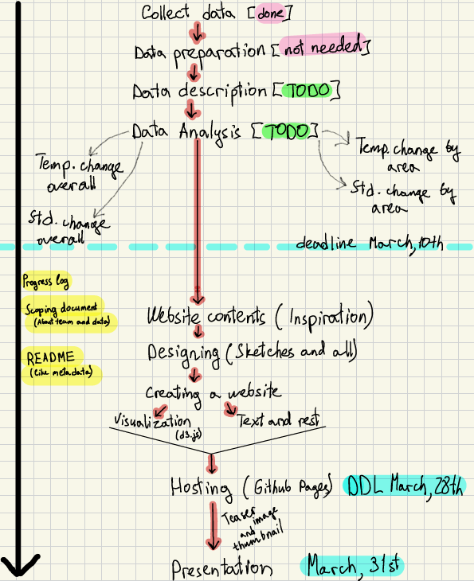

Only 1 missing value in the dataset, and we decided to neglect it and not prepare the data

**March 5**

Processing temperature data [Shitao Zhao]

Global temperature change & std analysis [Shitao Zhao]

**March 8**

Processing standard deviation data [Viktor Korotkov]

Descriptive analysis [Viktor Korotkov]

Code review [ALL (online)]